**IBM-Project-17179-1659629778**

**Assignment 2**

**Project Name:** Corporate Employee Attrition Analytics

**Name:** Sruti K

**Roll No:** SSNCE195002118

**Aim:** - Upload the dataset to Cognos Analytics, prepare the data, explore and Create Interactive Dashboard.

**Result:**

**1.Sales by Customer**

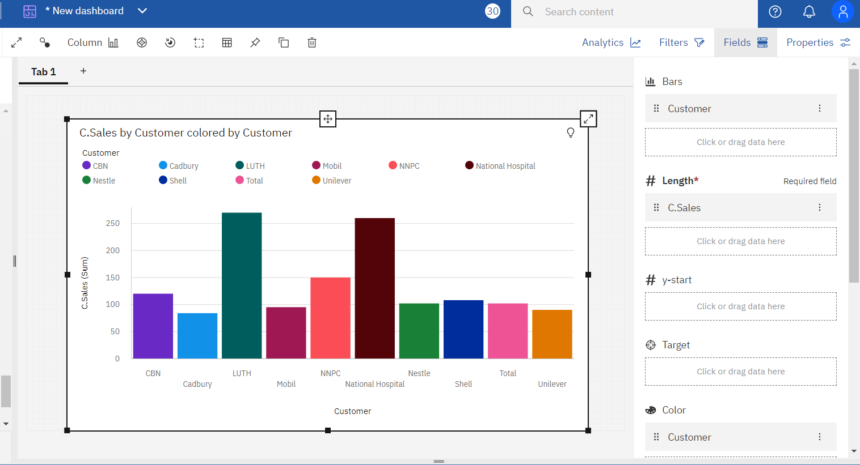

**2.Sales by Location**

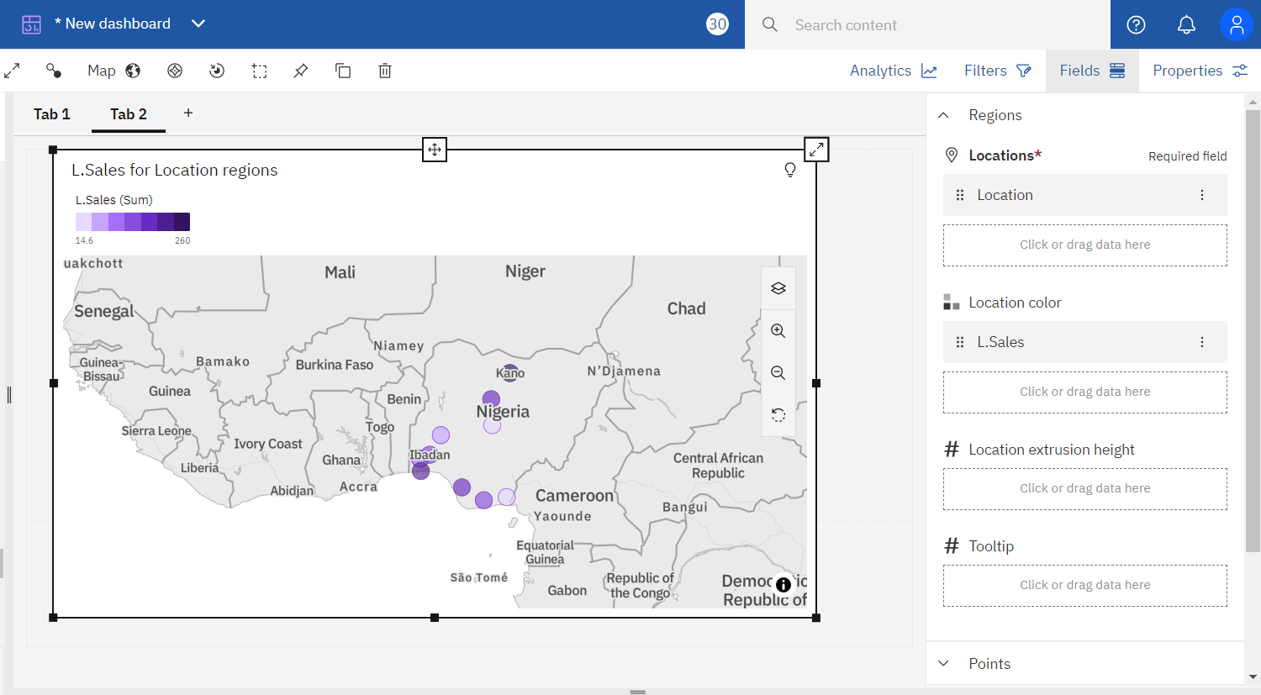

**3.Sales By Sales Representative**

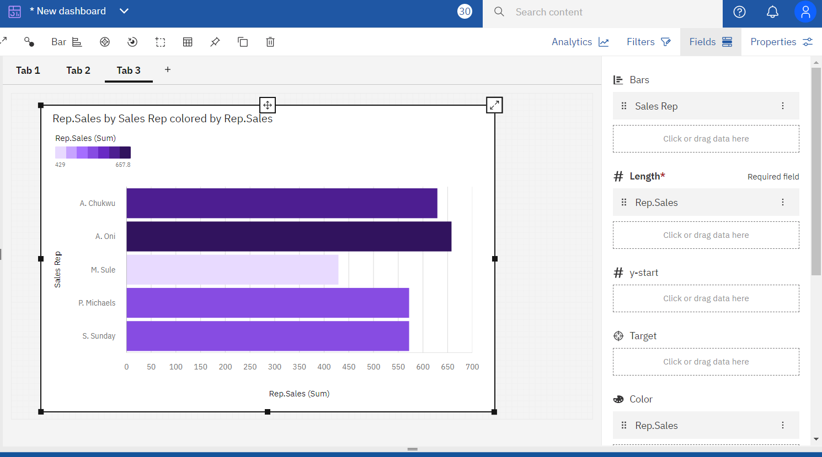

**4.Received Inventory From Supplier**

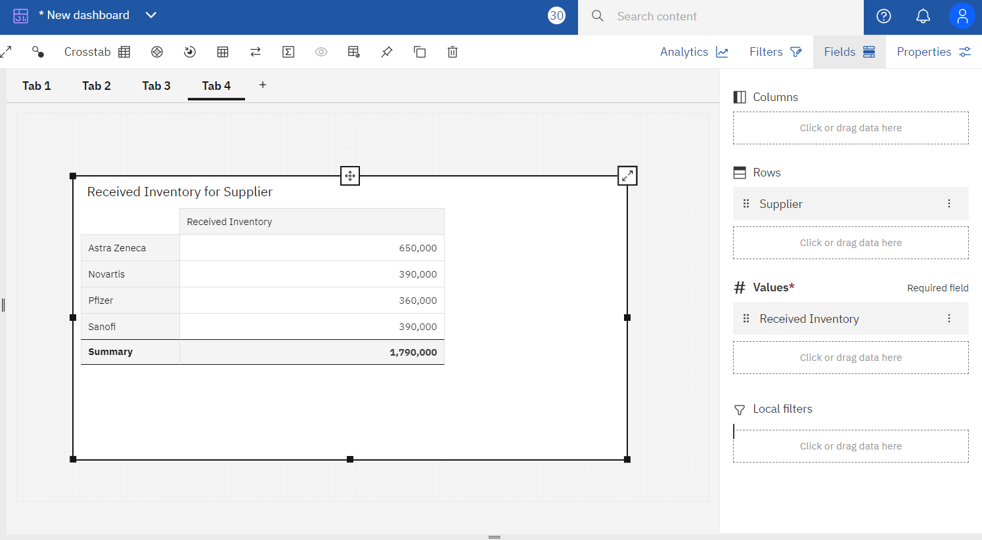

**5.Inventory Stock for Warehouse Locations**

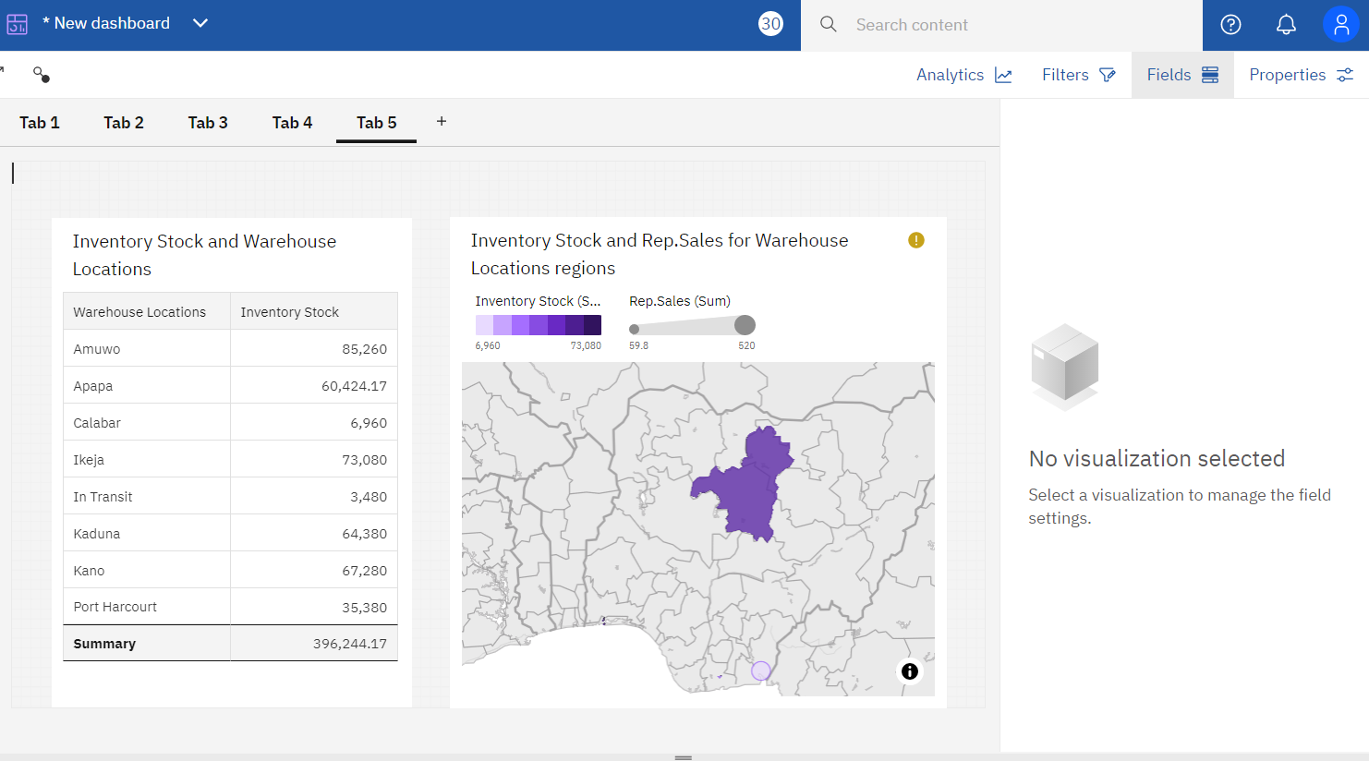

**6. Sales Trend**

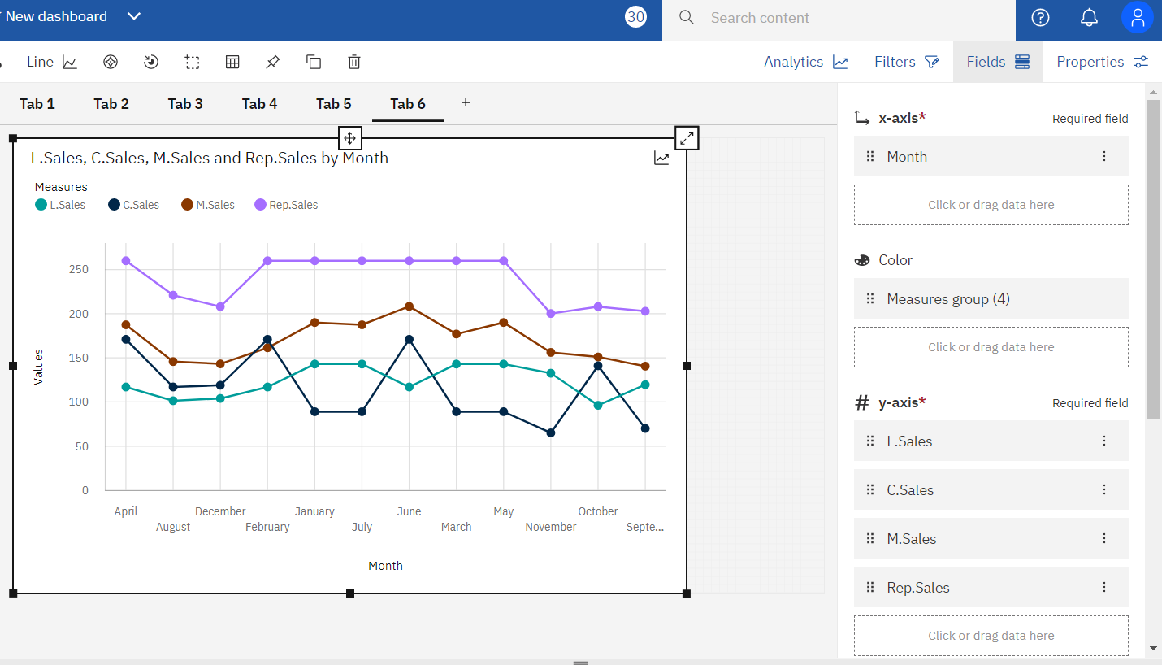

**7.Monthly Sales**

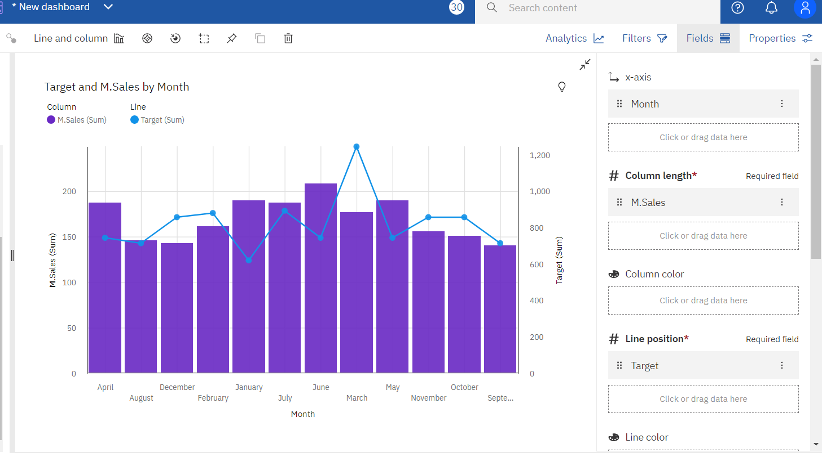

**8.Actual and Received Inventory by Month**

